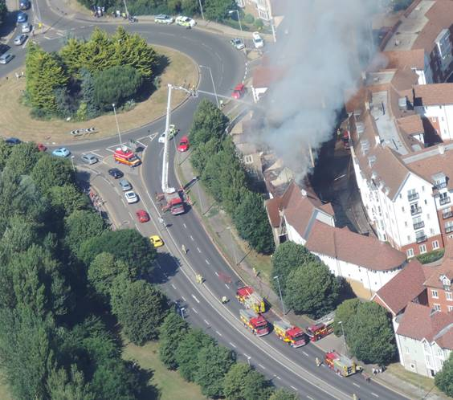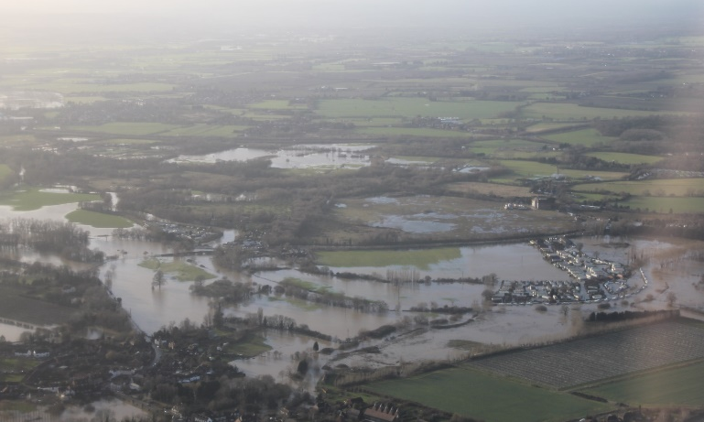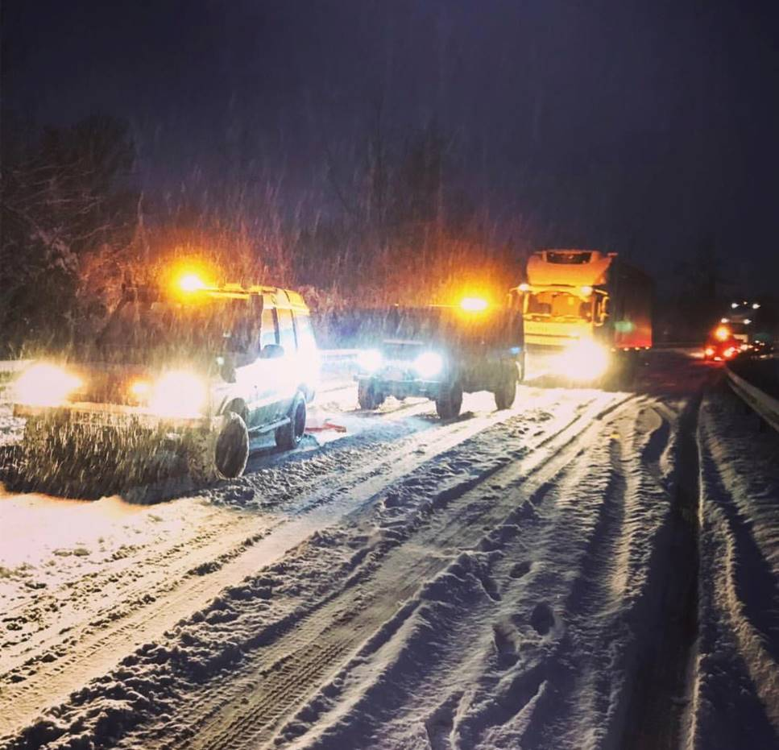

HOUSEHOLD

EMERGENCY

PLAN

**Emergencies can affect the county with little or no notice.**

**Being prepared can help reduce the effects on your life and your loved ones; reduce the need for support from others and enable you to support the vulnerable in your community.**

**Disruption to essential services such as water, gas and electricity, regional and national travel and telecommunications are all ways an emergency can affect our everyday lives.**

**A crisis happens when we least expect it.**

GO IN.

STAY IN.

TUNE IN.



If you are not involved in an emergency but are close by or believe you may be in danger, in most cases the advice is:

GO IN.

STAY IN.

TUNE IN.

|  |  |  |
| --- | --- | --- |
| Station | Frequency | Website |
| BBC Kent | 96.7, 97.6, 104.2 FM | www.bbc.co.uk/bbckent |
| Heart | 97.0, 102.8, 103.1 FM | www.heart.co.uk/kent |

**Creating an emergency box/bag**

**Be prepared.** Creating an emergency grab bag will help locate essential equipment quickly in an emergency. For more ideas on what to include in your grab bag visit “kentprepared.org.uk” and see the ‘Be prepared’ section. Some suggested items are:

|  |  |  |  |  |
| --- | --- | --- | --- | --- |
|  | Tick |  |  | Tick |
| Torch and spare batteries |  |  | First Aid Kit |  |
| Battery powered radio & spare batteries |  |  | List of useful contact numbers |  |
| Candles/matches |  |  | Toiletries/ Medication |  |
| Copy of this plan |  |  | Mobile phone & charger |  |

|  |  |
| --- | --- |
| In case you are unable to leave the house it is suggested you should have: | In case you are stuck in your car due to severe weather or congestion it is suggested you should have: |

|  |  |  |  |  |
| --- | --- | --- | --- | --- |
|  | Tick |  |  | Tick |
| Bottled Water |  |  | Blankets |  |
| Ready to eat food (tinned) |  |  | Torch spare batteries |  |
| Bottle/tin opener |  |  | Water |  |
|  |  |  | Phone charger |  |

|  |  |
| --- | --- |
| Location of where emergency box/bag is kept |  |

List of current medication

**Once completed it would be advised to laminate this form and then store in a safe**

|  |  |  |  |
| --- | --- | --- | --- |
| Medication Name | Dose | When taken | Who takes it |
|  |  |  |  |
|  |  |  |  |
|  |  |  |  |
|  |  |  |  |

Complete the following sections and keep in a safe place where all in your household can easily access it

|  |  |
| --- | --- |
| Household Contacts details | |
| Name |  |
| Mobile |  |
| Work |  |
|  | |
| Name |  |
| Mobile |  |
| Work |  |
|  | |
| Name |  |
| Mobile |  |
| Work |  |
|  | |

|  |  |
| --- | --- |
| If you can’t contact each other, where should you meet/or who should you leave a message with? |  |
|  |
|  |

|  |  |
| --- | --- |
| If you are evacuated is there somewhere we can go? Friends or family? |  |
|  |
|  |
|  |

|  |  |
| --- | --- |
| Who will be responsible for picking up the children from school? (if applicable.) |  |
|  |
|  |

Emergency telephone numbers

|  |  |  |  |
| --- | --- | --- | --- |
| Emergency services | 999 | Local authority |  |
| NHS out-of-hours | 111 | Doctor |  |
| Police non-urgent  Local Police Station | 101 | School |  |
| Power cut | 105 | Other |  |

Important documentation and information

|  |  |
| --- | --- |
| Insurance Company |  |
| Insurance phone number |  |
| Home insurance |  |
| Policy number |  |
| Other (Please list) |  |
|  |  |

**place, e.g. upstairs (if available) and provide a copy to family or friends.**

Have you turned off the following? Who is responsible?

|  |  |  |
| --- | --- | --- |
|  | Tick | Where are these utilities located at your property? |
| Gas |  |  |
| Electricity |  |  |
| Water |  |  |

If you are in the position where you are able to offer help to your community start by checking that your neighbours are alright, make a record of their details here:

|  |  |  |  |
| --- | --- | --- | --- |
| Name | Address | Telephone | Mobile |
|  |  |  |  |
|  |  |  |  |
|  |  |  |  |

Useful websites

|  |  |
| --- | --- |
| Kent County Council  www.kent.gov.uk | BBC Kent  www.bbc.co.uk/kent |
| National Flood Forum  www.floodforum.org.uk | Environment Agency  www.environment-agency.gov.uk |
| Kent Resilience Forum  www.kentprepared.org.uk | Met Office  www.metoffice.gov.uk (weather ready) |

Other useful information

